1. **Agenda**:
   1. Different Data Types.
   2. Associated operations based on data types.
2. 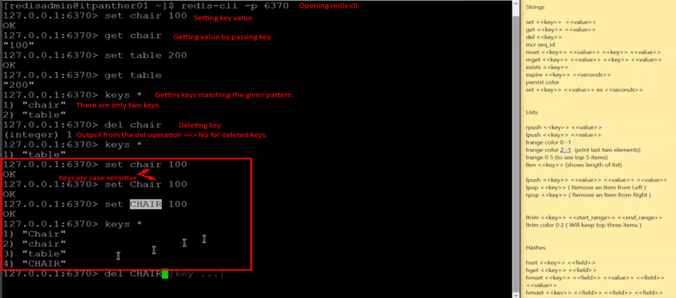
3. 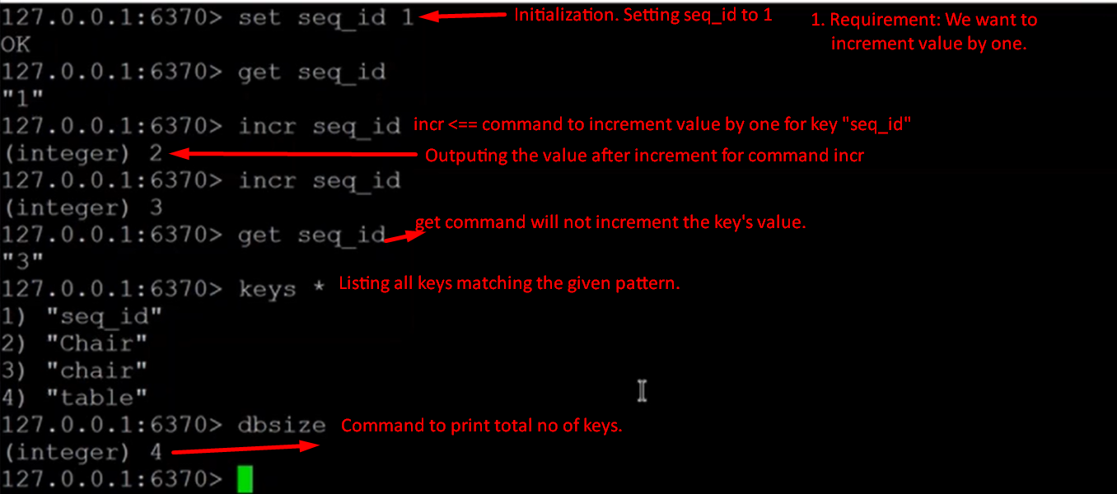
4. **Command**: **m**set 🡸 To set **m**ultiple key value pairs in one go

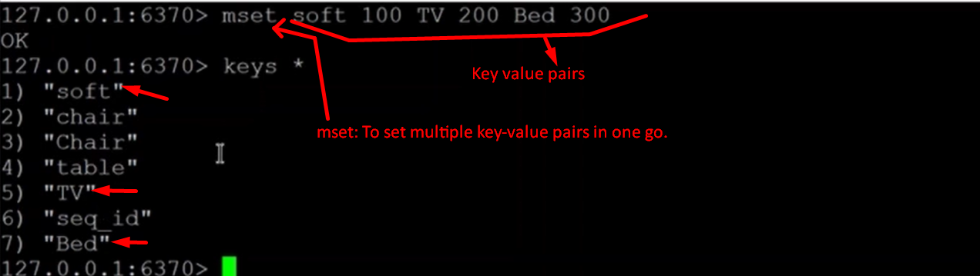  
**NOTE**: mset is **faster** than set as it sets values in one go.

1. **Command**: mget 🡸 To get multiple values by specifying multiple keys.  
   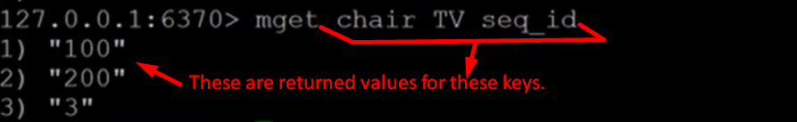  
   **NOTE**: Faster as get operations for all specified keys are performed in one go.
2. Checking whether a key or keys exist or not. **Command:** exists kye [key …]

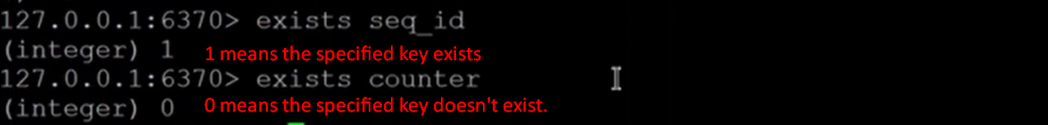

1. Setting the expiration time for key:  
     
   Ex: Expiration for seconds.  
   PX: For milliseconds.  
   **Use Case**: This is used more in the use cases, where you want some value to be existing for some particular time.   
   **For example**: If you want to make some service available for 2 hours.  
   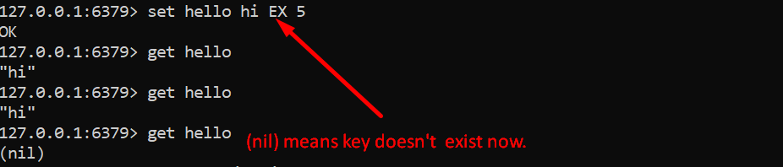
2. Persisting key-value permanently.  
   **Command** 🡺 **persist key  
   NOTE: No value part is in the command.**  
   The value exists forever.   
   Either set expiration time for the key or delete it manually now.
3. **Command to delete all keys**: flushall
4. 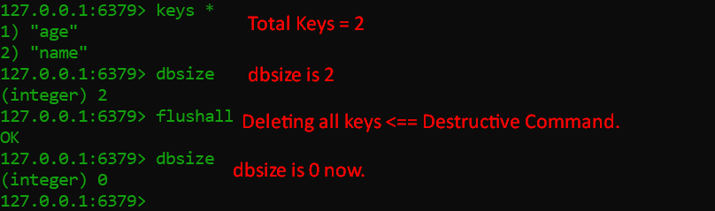

Working with Redis List

1. On redis list, you push elements from left or right side.
2. lpush, rpush, lrange,   
   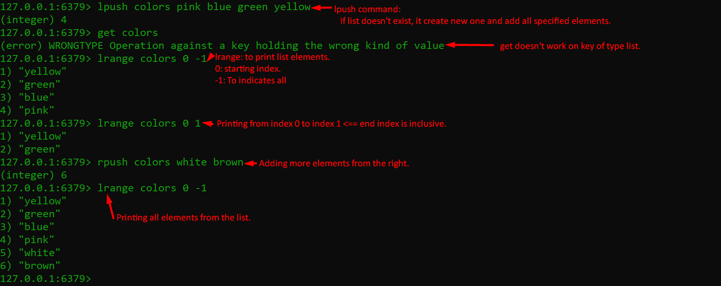
3. 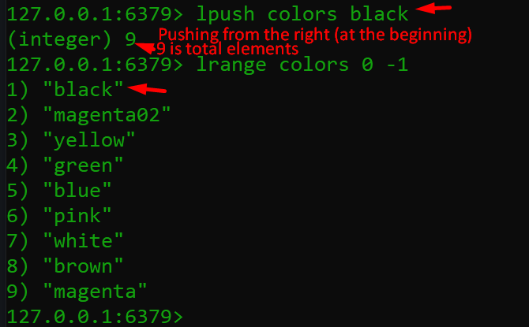
4. **Command to get the no of elements in a list**llen colors:  
   
5. **Order of elements when they are inserted into the list**.  
   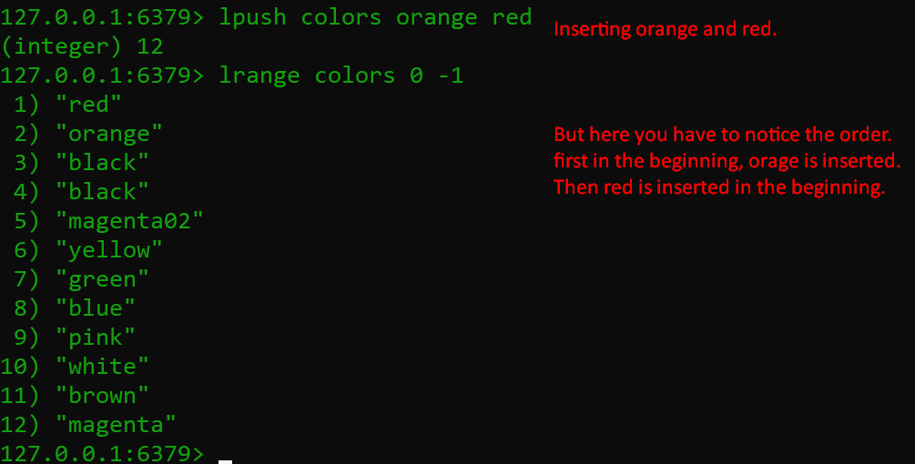
6. Command to pop a value from the list  
   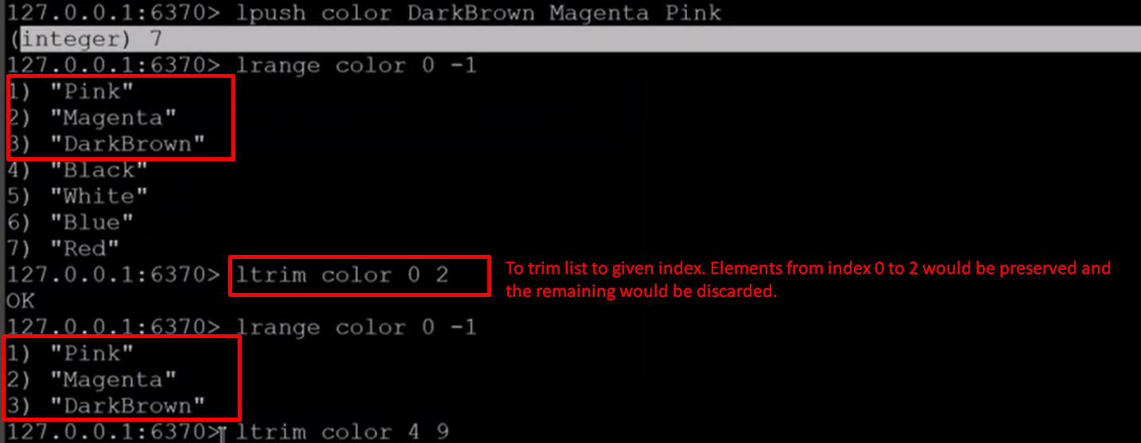
7. 